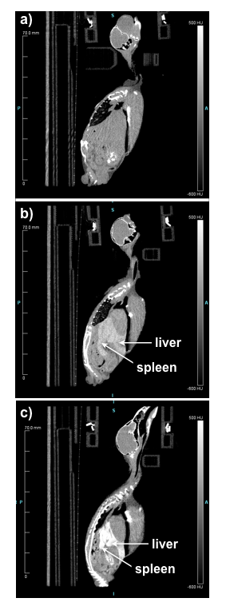
Supplemental Fig 1. Sagittal view computed tomography (CT) images from three different scans of the same animal, a female house sparrow (Passer domesticus), a) without contrast, and b) 2 hrs and c) two weeks after a 50 μl injection of the gadolinium-based contrast agent ExiTron Nano 12000, which is taken up by cells of the reticuloendothelial system and provides contrast of liver and spleen lasting several weeks after injection.

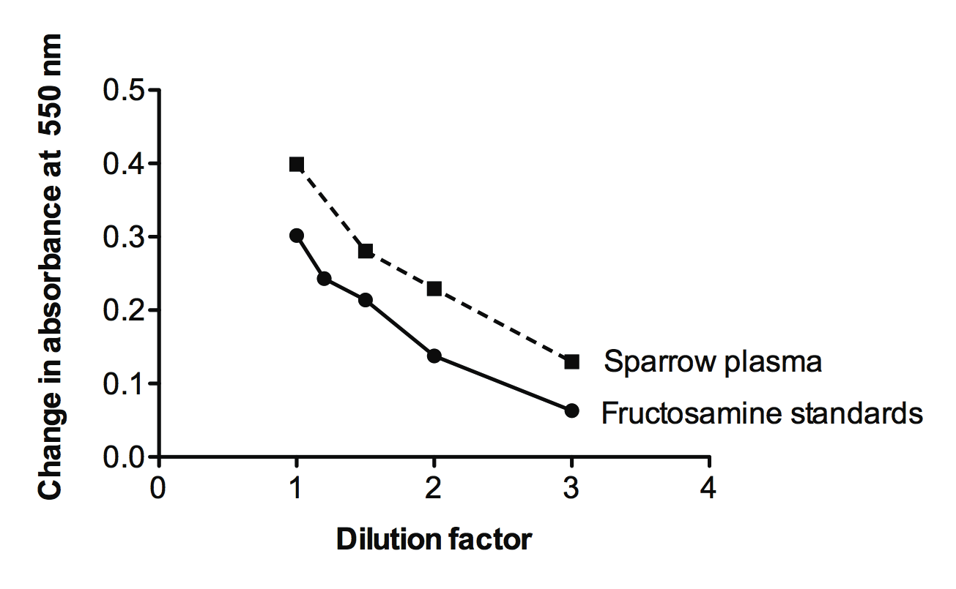
Supplemental Fig 2. Pooled house sparrow (Passer domesticus) plasma diluted at different concentrations with phosphate-buffered saline demonstrated parallelism to fructosamine standards using the MaxDiscovery Fructosamine Enzymatic Assay Kit (#5615-01, Bioo Scientific Corporation, Austin, TX, USA). This kit is based on the ability of ketoamines to reduce nitroblue tetrazolium to colored formazan dye, and involves calculating the change in absorbance at 550 nm from initial values to values after a 15 min incubation at 37°C.
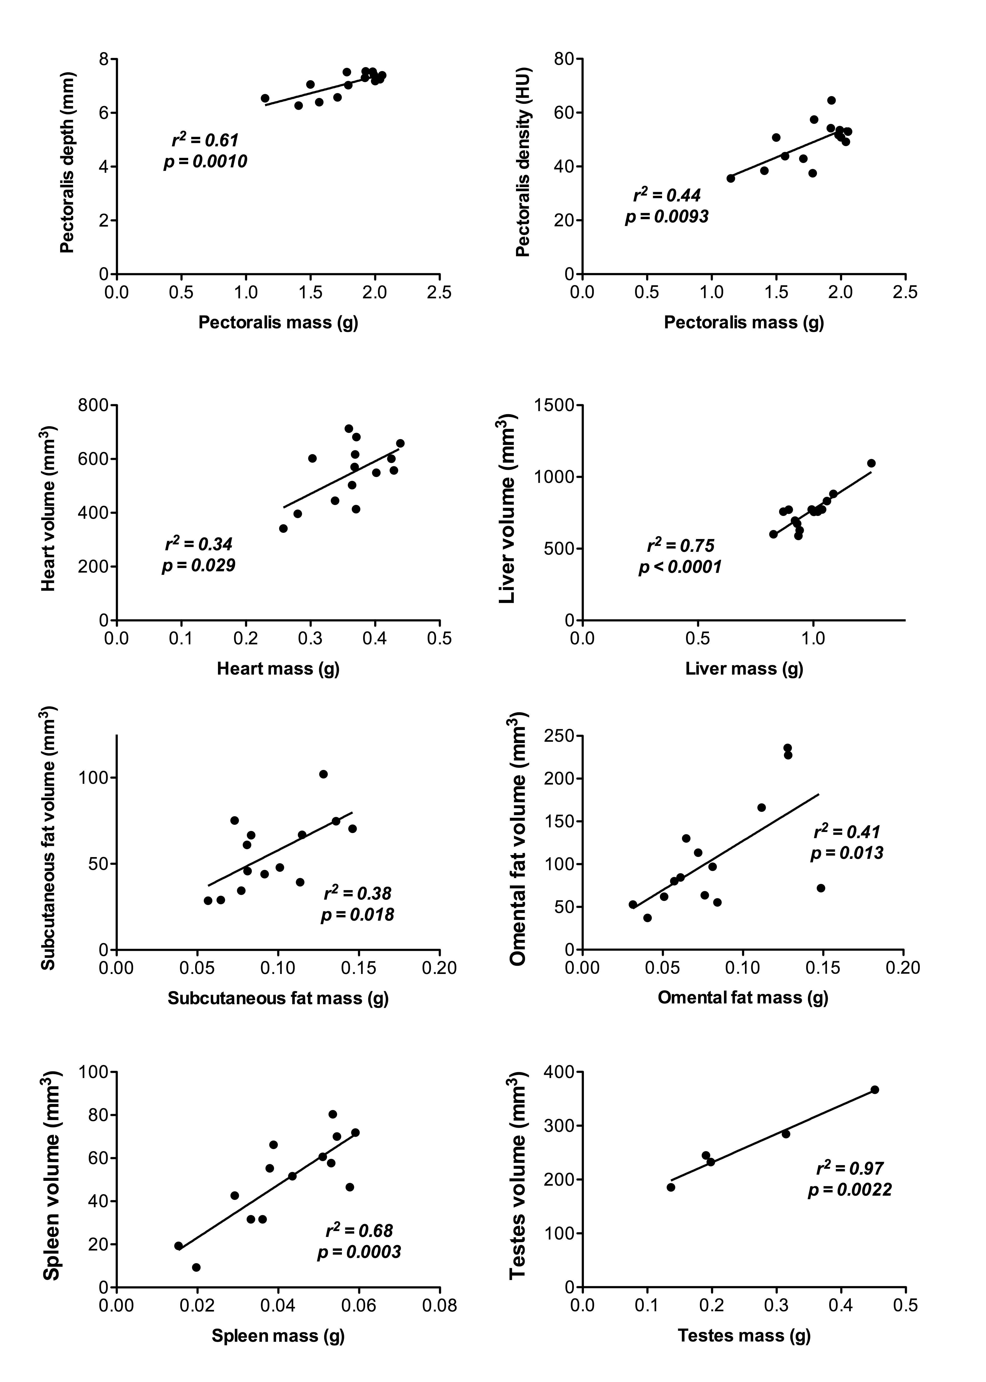
Supplemental Fig 3. A randomly-chosen subset of house sparrows (Passer domesticus; n=5 male, 9 female, euthanized 2 d after their last computed tomography (CT) scan), were fully dissected and tissues masses compared to 2 week post-captivity tissue volumes and pectoralis thickness and density measured using CT image analysis. In all cases, dissected tissue masses were significantly positively correlated with image-derived tissue measures, demonstrating that these measures are a good indicator of overall tissue size.

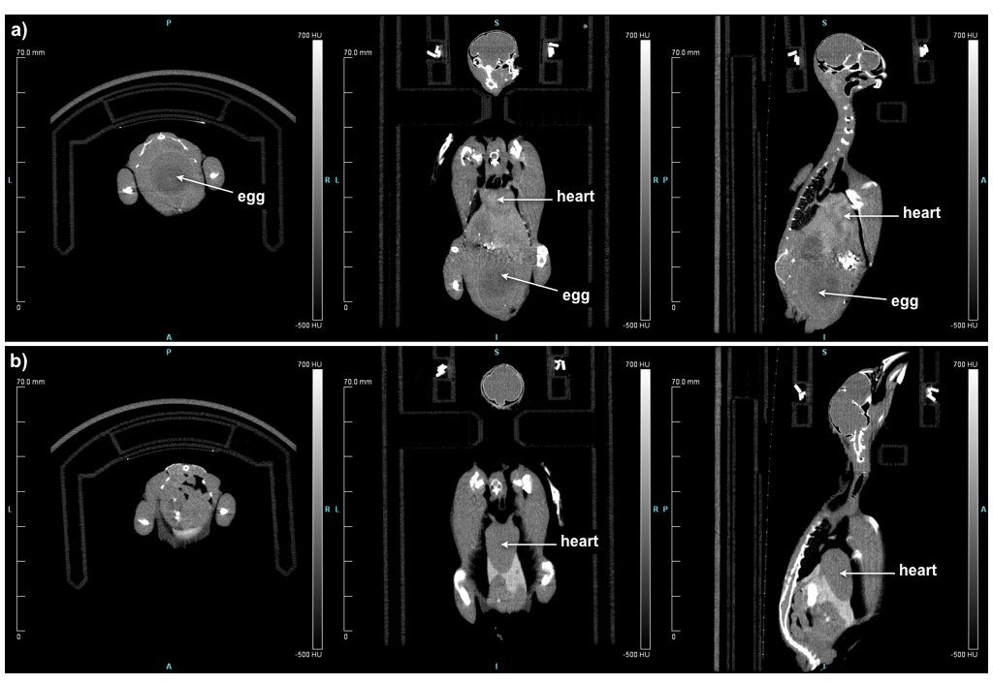
Supplemental Fig 4. Axial (left), coronal (middle) and sagittal (right) view computed tomography (CT) images from two different scans of the same animal, a female house sparrow (Passer domesticus), a) the day of capture, where an egg and large masses of reproductive tissue are visible in the body cavity, and b) after two weeks in the lab, where reproductive tissues have regressed and are no longer visible.

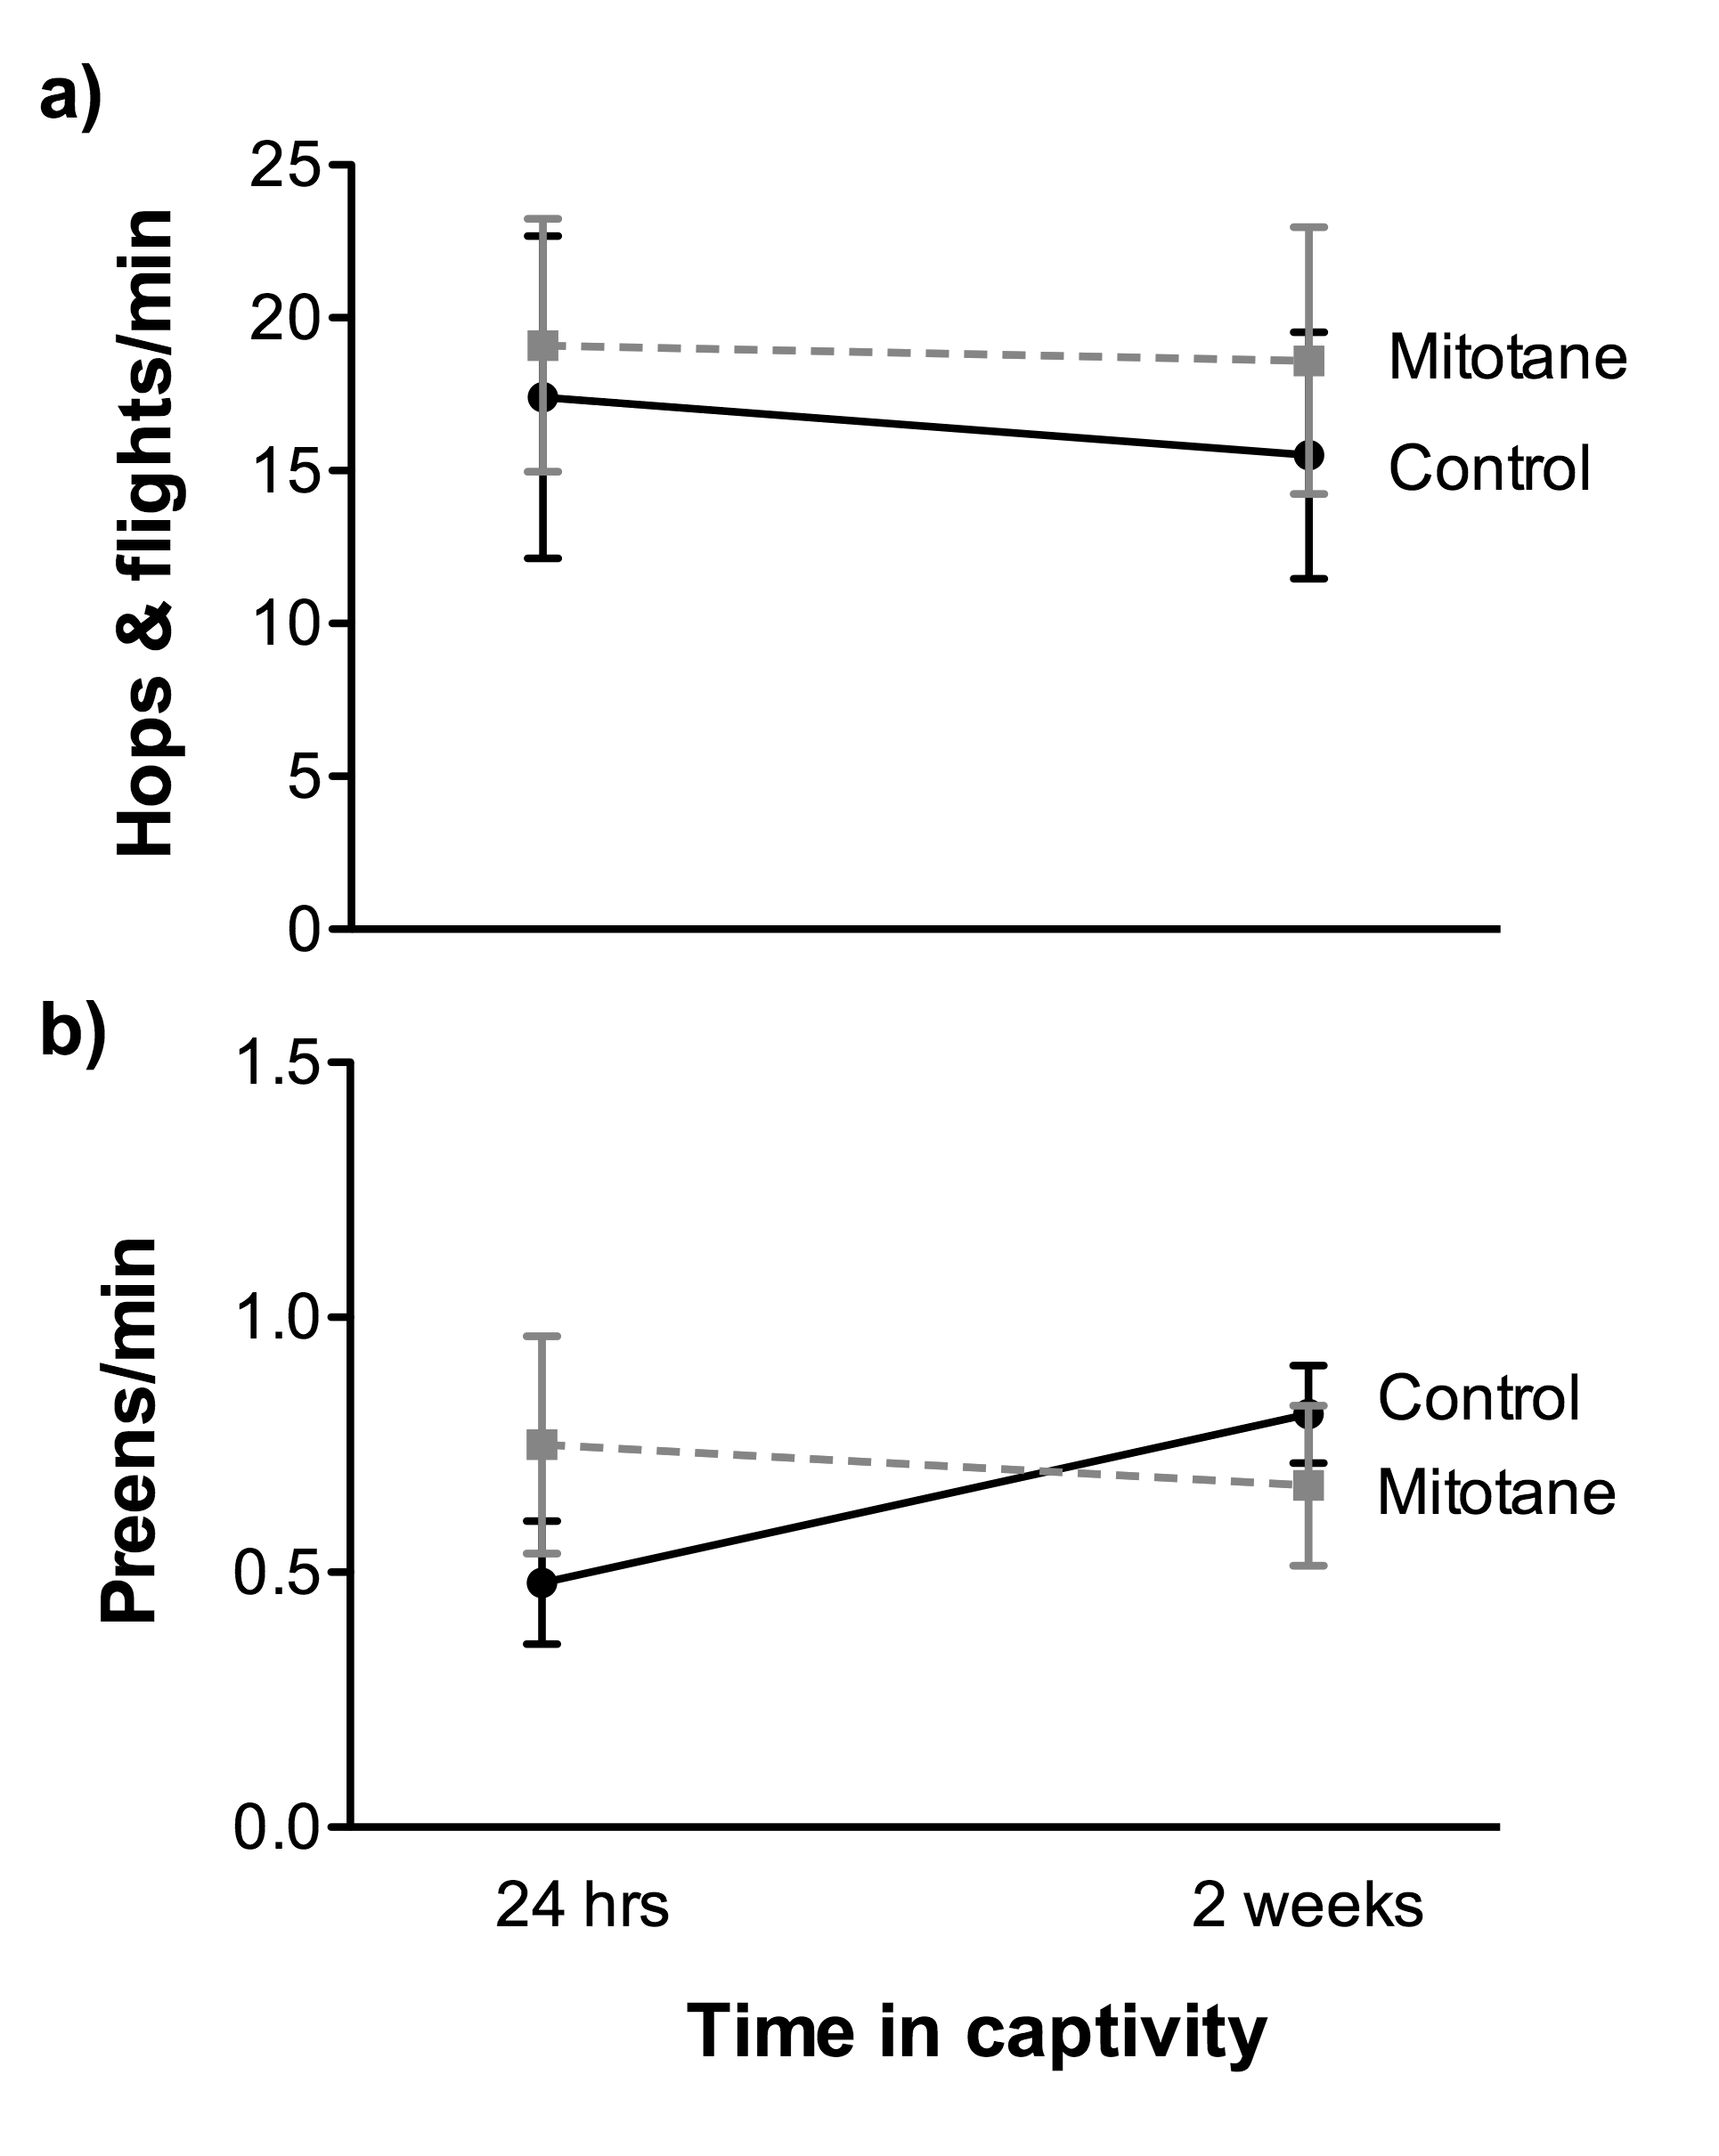

Supplemental Fig 5. Wild-caught house sparrows (Passer domesticus; n = 9 mitotane, n = 9 control) did not significantly change incidence of: a) number of hops and flights, or b) preening behavior with time spent in captivity, and there was no effect of the corticosterone-blocking drug mitotane on these behaviors. See text for more details on statistical analyses.

